Ethanology

# Concept Development

It isn’t everyday that we are able to take some time off our hands for a good drink so we thought, why not make the most of it? Everyone has their own choice of pubs they like to visit, be it the livelier types with live bands or the more exquisite and calmer ones with a very classy vibe. The aim of our web application is to integrate the needs and wants of the individual party goers into a simple, clean interface for allocation of pub crawl routes based on their personal tastes, at their own convenience.

# Personas

|  |  |
| --- | --- |
| Yong Gek Sum | |
| Age : 20  Occupation : Exchange Student  Relationship Status : Single  Location : Glasgow, Scotland | **Characteristics** |
| New to Glasgow  Wishes to expand his social circle  Price conscious  Wants to tour Glasgow to know of the best hangouts |
| Related image |
| **Hobbies** |
| Gaming  Reading  Procrastinating |
| **What he looks for in a Pub Crawl** |
| Affordable drinks  New friends  Exciting Nightlife |

|  |  |
| --- | --- |
| Tarb Fraenan | |
| Age : 33  Occupation : Assistant Lecturer @ UoG  Relationship Status : It’s Complicated  Location : Glasgow, Scotland | **Characteristics** |
| Party Animal  Drinks as a form of escape from reality  Very Sporty  Loves a good read |
| Related image |
| **Hobbies** |
| Hiking  Travelling  Writing Food Reviews |
| **What she looks for in a Pub Crawl** |
| Potential relationships  Potential friendships  The next best place to chill |

|  |  |
| --- | --- |
| Reich Clarkson | |
| Age : 46  Occupation : Businessman  Relationship Status : Married  Location : Glasgow, Scotland | **Characteristics** |
| Loves exquisite drinks  A sucker for items with class  Brands mean everything |
| Image result for american businessman |
| **Hobbies** |
| Stock trading  Golf  Wine tasting |
| **What he looks for in a Pub Crawl** |
| Potential high-end bars/pubs for a night out  Places that he could recommend his clients to  Places that serve his favorite drinks in the best way possible |

# Scenarios

Yong Gek Sum

* A student that attends UoG. He is an international student and has come over to the main campus with his friends for an oversea exchange program.
* Despite a lower than average tolerance for alcohol, he fully intends to experience the rich Scottish drinking culture.
* He is a student, and is money conscious, and does not have a vehicle for transportation.
* He doesn’t have a drink which he prefers, choosing he drinks based on price above all else.

1. He spends most of his time at the University campus or at the dorm. He wants to experience a pub crawl in the UK, being inspired by movies.
2. He signs into shots.
3. He searches for in a list of role-based preferences, in which she selects “Golden Mile”.
4. The app then lists all nearby bar/pubs that fit the category
5. It will then generate the best route to visit the best 12 pubs.

Tarb Fraenan

* An assistant lecturer at UoG, a young woman that wants to let loose her inner child and dance her troubles away.
* She frequents places that are very lively, loud and have a bunch of people dancing.
* Her preferred drink is anything that pack a punch. She has a habit of smoking, leading to her preferring bars that has an open-air section, or allow smoking.
* She is well-versed in Scottish culture and has a degree of familiarity with the area and city around the UoG campus.

1. As an avid party-goer, Tarb is always on the lookout for the wildest parties around.
2. She signs into shots.
3. She searches for in a list of role-based preferences, in which she selects “Wild Parties”
4. The app then lists all nearby bar/pubs that fit the category, with description of each.
5. It will then generate the best route to visit each location based on her choice.

Rich Clarkson

* A British businessman, after making deals all day, he likes to relax with a quiet drink. Due to his job he must fly all over the globe.
* Enjoys the finer things in life. Prefer to use as little energy as possible. Since he in a different city every week, he needs an app to find a bar that fits his preferences.
* Doesn’t like to use google maps app, as they do not curate their selection of bars, only showing all bars nearby.
* A non-native to Scotland. Finding a nice quiet bar to relax could be difficult considering the frequency and differing locations in his travel.

1. As the sun sets, Businessman Clarkson, desires to relax at a bar/pub which is more classy
2. He signs into shots.
3. He searches for in a list of role-based preferences, in which she selects “Black-Tie Only”.
4. The app then lists all nearby bar/pubs that fit the category, with description of each.
5. It will then generate the best route to visit each location based on his choice.

Rajesh Indriyati

* An IT consultant from India, he has come over to work in Scotland. He and his friends, love to let their hair down after work.
* Though not a heavy drinker himself, he enjoys a drink himself, every now and then.
* Although there is a myriad of apps for finding good food around Scotland, he has yet to find an app that would recommend a personalized selection of bars and pubs, based on the input of the user.

1. Raj and his friends, like bars that play blues and jazz live, while they unwind and drink.
2. He signs into shots.
3. He searches for in a list of role-based preferences, in which she selects “Great Hits All Night Long”.
4. The app then lists all nearby bar/pubs that fit the category, with description of each.
5. It will then generate the best route to visit each location based on his choice.

Tyson Freeman

* After a long and successful career as a boxer. Mr. Tyson has decided to hang up his boxing gloves and retire to the countryside.
* He has sustained multiple injuries throughout his career and has taken to drinking to cope with the pain.
* Even though he hasn't been in the ring for a long time, he continues to drink, out of habit.
* As a retiree, Freeman regularly visits mainland Europe.
* He frequently looks for bars and pubs, with good food, so that he can enjoy his time eating and drinking.

1. Tyson is in a new city, he wants to relax at a bar/pub.
2. He signs into shots.
3. He searches for in a list of role-based preferences, in which she selects “Chef & Brewer”
4. The app then lists all nearby bar/pubs that fit the category, with description of each.
5. It will then generate the best route to visit each location based on his choice.

# Wireframes

wireframes/sketches for all key screens and actions

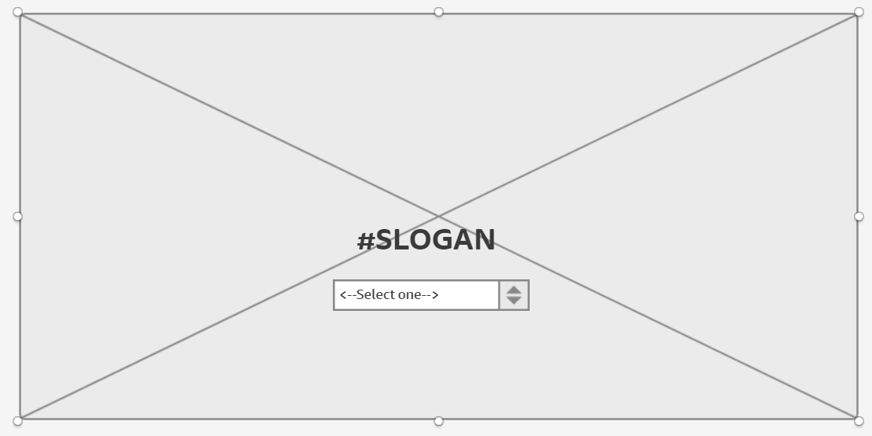

This is the Home Page where users will be directed to upon entering the website.

The background of the website will be an image.

There is a slogan as well as a dropdown that has options that the user can select according to what they feel like they care under, for example, party animal, student etc.

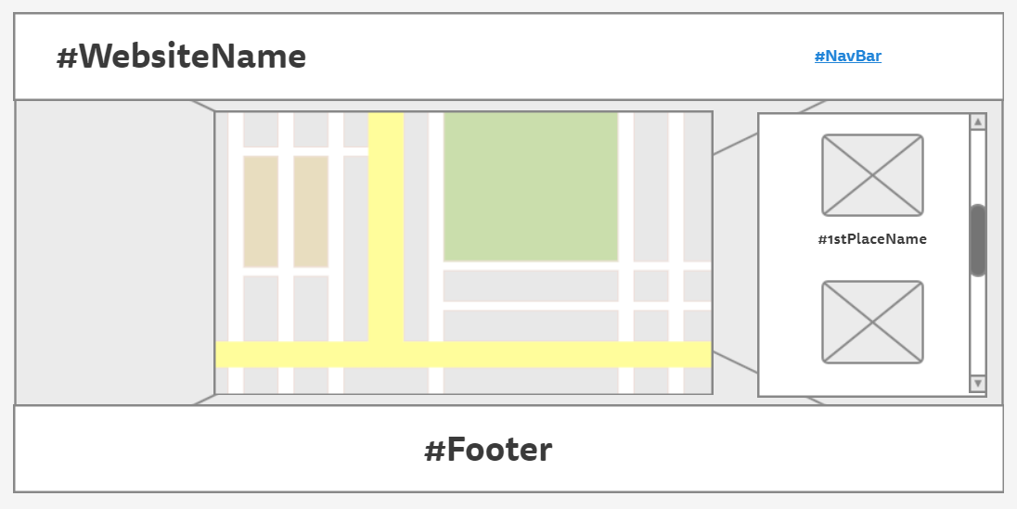

Upon selecting, it will direct them to the next page with a map with smooth scrolling

Map will show the bars and the path that traces from bar to bar in the map according to the audience type.